

Microsoft account

[Company name]



Contents

[BIOS 4](file:///C:\Users\tscox_000\Documents\Phi\BitTorrentSync\Engineering%20Notebook\Omega\PHI%20Notebook%202014-2015\PHI%20Notebook%203-23-15.docx#_Toc414899719)

[MEETING LOG 10](file:///C:\Users\tscox_000\Documents\Phi\BitTorrentSync\Engineering%20Notebook\Omega\PHI%20Notebook%202014-2015\PHI%20Notebook%203-23-15.docx#_Toc414899720)

[HARDWARE 71](file:///C:\Users\tscox_000\Documents\Phi\BitTorrentSync\Engineering%20Notebook\Omega\PHI%20Notebook%202014-2015\PHI%20Notebook%203-23-15.docx#_Toc414899721)

[SOFTWARE 101](file:///C:\Users\tscox_000\Documents\Phi\BitTorrentSync\Engineering%20Notebook\Omega\PHI%20Notebook%202014-2015\PHI%20Notebook%203-23-15.docx#_Toc414899722)

[FUNDRAISING 117](file:///C:\Users\tscox_000\Documents\Phi\BitTorrentSync\Engineering%20Notebook\Omega\PHI%20Notebook%202014-2015\PHI%20Notebook%203-23-15.docx#_Toc414899723)

[TEAM ORGANIZATION 122](file:///C:\Users\tscox_000\Documents\Phi\BitTorrentSync\Engineering%20Notebook\Omega\PHI%20Notebook%202014-2015\PHI%20Notebook%203-23-15.docx#_Toc414899724)

[PROMOTE VIDEO 128](file:///C:\Users\tscox_000\Documents\Phi\BitTorrentSync\Engineering%20Notebook\Omega\PHI%20Notebook%202014-2015\PHI%20Notebook%203-23-15.docx#_Toc414899725)

[TROUBLESHOOTING 132](file:///C:\Users\tscox_000\Documents\Phi\BitTorrentSync\Engineering%20Notebook\Omega\PHI%20Notebook%202014-2015\PHI%20Notebook%203-23-15.docx#_Toc414899726)

[OUTREACH 144](file:///C:\Users\tscox_000\Documents\Phi\BitTorrentSync\Engineering%20Notebook\Omega\PHI%20Notebook%202014-2015\PHI%20Notebook%203-23-15.docx#_Toc414899727)

[APPENDICES 151](#_Toc414899728)



# BIOS

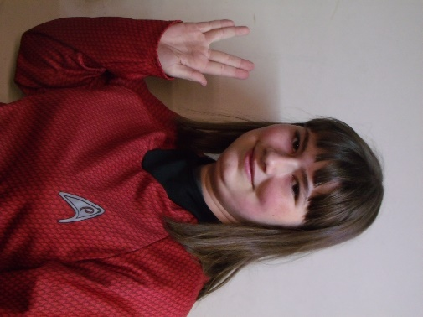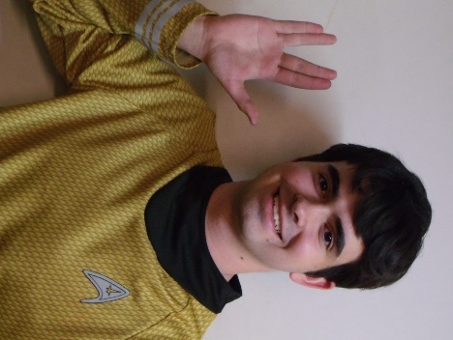

Kaitlin Cox 3rd year on team

FAVORITE JOB ON TEAM: Driving the robot and working in the notebook, as well as learning to write basic software

HOBBIES: Creative writing- particularly medieval fantasy stories and fanfiction- art, computer programming and game design, and roleplaying

INTERESTING FACTS: Over the course of the 2013/2014 school year I wrote the rough draft for a novel that is more than 110,000 words in length. I am currently editing the manuscript. I am also attempting to make a computer game using the Construct 2 platform. I am a keraunomaniac, which means I have an abnormal obsession with lightning. Not everything I say is meant to be taken literally.

Jonathan Lokos 4th year on team

FAVORITE JOB ON TEAM: Team lead, hardware, 3D modeling, and driving.

HOBBIES: Robotics, airsoft, SCUBA diving, kayaking, and hiking.

INTERESTING FACTS: I am known in the robotics community as the “Beard of Knowledge”. I have been building and designing since I was three years old.

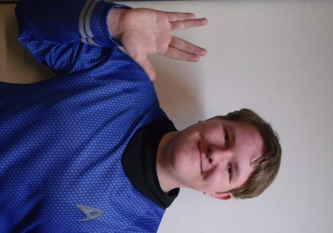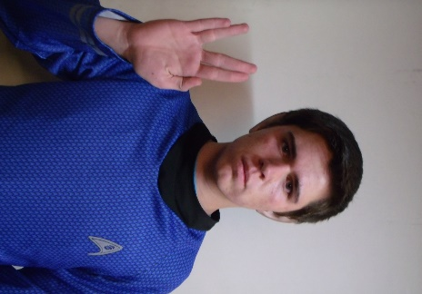

Noah Killian 2nd year on team

FAVORITE JOB ON TEAM: Software

HOBBIES: Programming, Cubing, League of Legends, Electronics

INTERESTING FACT: I’m too lazy to procrastinate so I’ll procrastinate later.

Eddie Pierce 3rd year on team

FAVORITE JOB ON TEAM: Hardware design, LabView programming

HOBBIES: Playing clarinet, PC gaming, novel writing, sketching, airsofting

INTERESTING FACTS: I have been known on the team as the designated target for all robots. For my first year on the team, I was called the Dementor, but that has since changed to Bones.

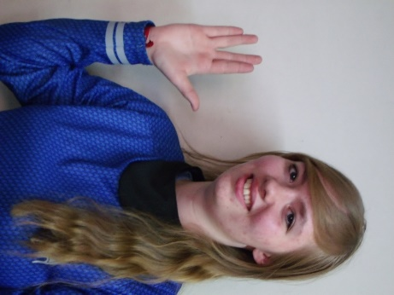

Holly Creech 1st year on team

FAVORITE JOB ON TEAM: Working on the notebook, and learning hardware.

HOBBIES: Playing the piano, teaching the piano, and writing.

INTERESTING FACTS: I love owls, chocolate, listening to music, and spending time with friends.

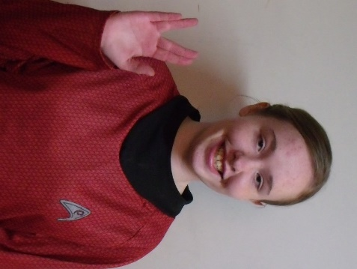

Hanna Creech 1st year on team

FAVORITE JOB ON TEAM: Hardware

HOBBIES: Photography, Baking, Piano (music), Swimming, And Drawing

INTERESTING FACTS: I enjoy my pets especially my dog and guinea pig. I’ve been doing piano for over 6 years and the flute for 1. My favorite color is blue.

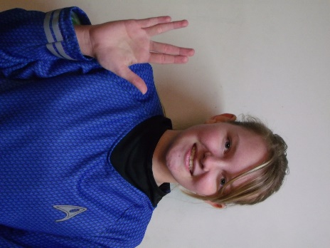

Becky Pierce 1st year on team

FAVORITE JOB ON TEAM: Software

HOBBIES: Playing volleyball and softball, running cross country and track, baking, piano

INTERESTING FACTS: I’ve been homeschooled my whole life. I helped start an FLL team in 2011. I used to be on a bowling team. I hate looking for nonexistent screws. I love the Dodgers.

Sergei Cox 1st year on team

FAVORITE JOB ON TEAM: Hardware

HOBBIES: Softball, building things, reading.

INTERESTING FACTS: People call me different things and say my name wrong. I’m the weirdest person I know.

****

Bill Lokos is a structures engineer at NASA Armstrong Flight Research Center at Edwards California where he has worked for 39 years.  Bill has worked with aircraft structural load measurement, ground loads testing, in-flight deflection measurement, and static structures safety of flight.  He has performed testing and research with drones, the X-29A, F-15, F-16, F-18, F-106, C-141, B-1, F-111, Shuttle Orbiter, Gulfstream GIII, and the SOFIA 747 airborne observatory and has published his research internationally.  He provides advice to the robotics team on safe use of tools, material properties, mechanical design, and electrical wiring principles.  While the team prefers to build or form their own parts, on the occasions when fabrication help is desired, he is a link to the NASA Armstrong fabrication shops.

****

Tim Cox is an engineer in the controls and dynamics branch at the NASA Armstrong Flight Research Center. This is his first year mentoring an FTC team but he has mentored an FLL team in previous years. He enjoys teaching the engineering process and especially spending time with his son and daughter who are on the team.

Quinten Pierce is a software engineer for Spirent Communications.  Both of his children, Eddie and Becky, are involved in the PHI Omega team.  This is Mr. Pierce's first year mentoring an FTC team, although he mentored an FLL team for 3 years, building that team up from scratch.

Dylan Stinson is a sophomore at Antelope Valley College and planning to transfer to University of Long Beach for an Electrical Engineering degree. He have been with first for 12 years over half his life. He started with FIRST LEGO League in 2003 and went tell 2005. He is a founding member of PHI robotics. He is a self-taught programmer and a teacher of programing. He is also an expert / veteran of FIRST Tech Challenge.

# MEETING LOG

****

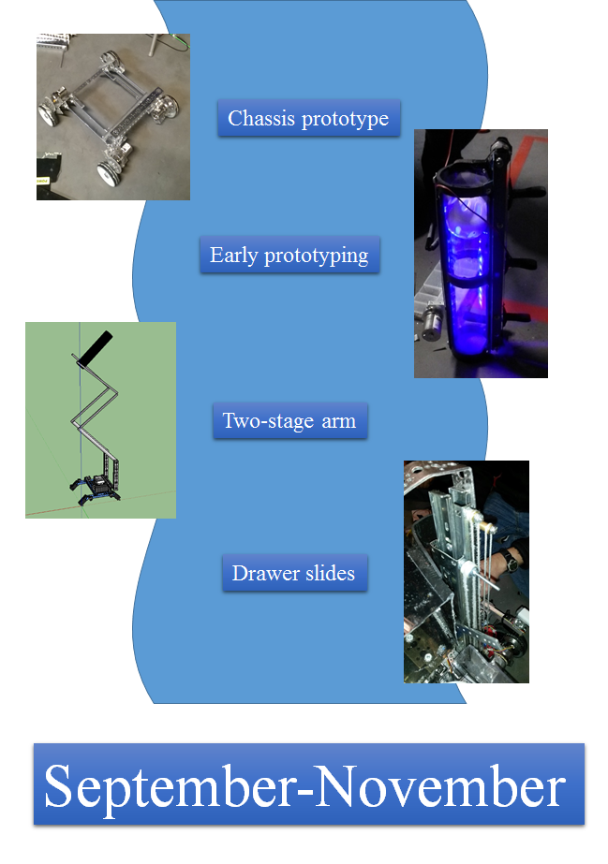

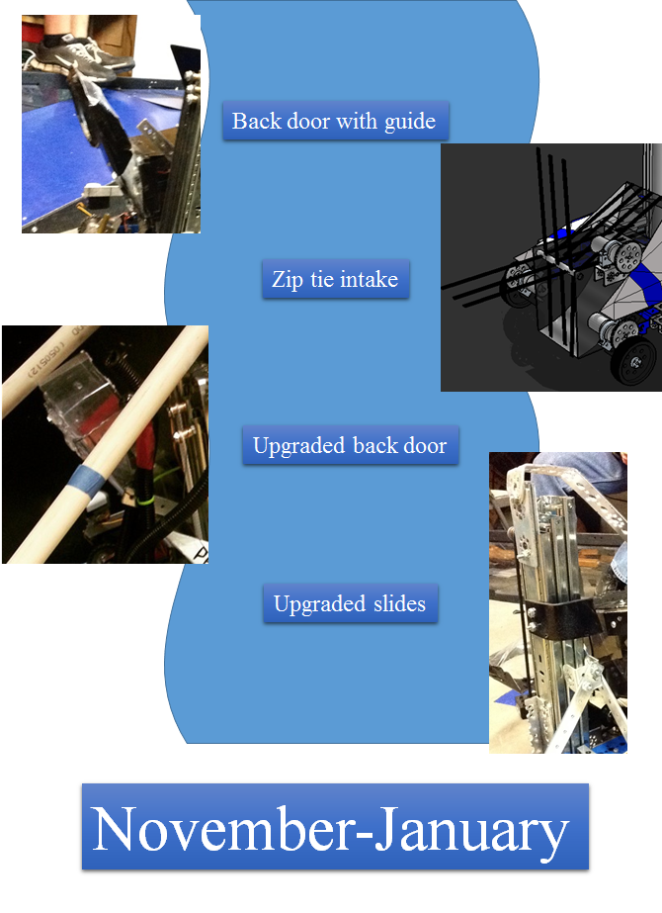

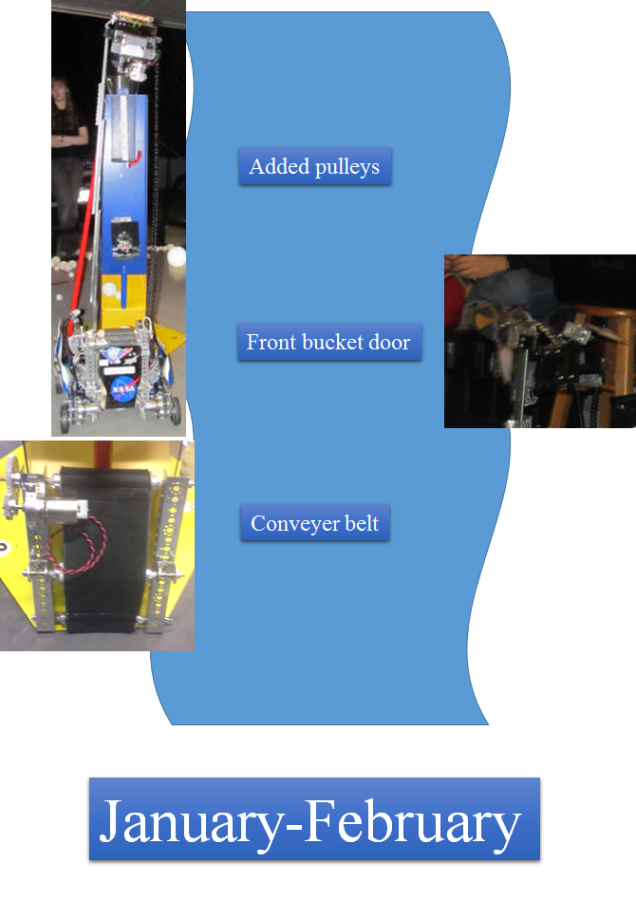

A BRIEF SUMMARY OF OUR YEAR

Phi Omega has come up with several innovations, both in hardware and software, this year. These pages provide a basic summary of those innovations.

*Hardware*

Suspension

Perhaps the most unique part of our robot is it's independent passive suspension system. The suspension was first conceived in a brain storming session last year to determine a way of dampening vibration and allowing for better ground clearance. The suspension works by having each motor and wheel mounted on a free moving, self-contained motor nacelle. The nacelles are mounted on axels that act like hinges allowing them to move up and down. The nacelles are then secured in the down position by surgical rubber tooling that acts as the shock absorber. The suspension allows us to drive off the sides of the ramp without damaging the electronics, it acts to dampen the vibration in our accelerometer and gyro, and it allows us to drive smoothly over the fallen kickstands.

Modular chassis

This year our robot is featuring a predesigned modular chassis. The chassis was designed before the season started as a summer project and was dubbed the KR4. Since we did not know what the competition would be, we used experience from past years to develop a chassis that could be adapted to a wide variety of challenges. We first selected the Kraken style of chassis that was first designed by PHI Robotics five years ago. The Kraken chassis has a high degree of ground clearance to allow it to drive over a wide variety of field elements. We then implemented our Nacelle based suspension to give the chassis even further capabilities. We then looked into how to make the Chassis modular. To do this we used the CAD modeling software Google SketchUp. We spent several months and came up with a rail and bracket system that allows us to slide the center support and mounting bars forward and backward to accommodate any subsystem that we might need.

3D printing

This has been the first year that PHI robotics has been able to add 3D printing to a wide array of tools. Late last year, our team was introduced to the architectural design software SketchUp. We then spent some time trying to acquire the Auto Desk design software however our computers failed to run it so we were stuck with using SketchUp. Last summer we spent a considerable amount of time creating our new chassis with our CAD software. We however did not have enough funds to buy our own 3D printer so we went and asked NASA for help. NASA Armstrong's 3D printer lab offered their services as well as some guidance to help get our parts printed. After some consulting with the NASA engineers, we completed our design and had our first 3D printed parts made. After some trial and error, we have refined our 3D designs and now use 3d printed Nacelles and brackets on our chassis. PHI is now the leading authority on 3D printing amongst the FTC teams in our area and we offer assistance to team in need of 3D printed parts.

Carbon fiber shields

This season our robot is sporting new high tech composite shields made of carbon fiber. Initially the shields where going to be made of fiber glass. We started the process before our second competition this year by using our CAD software to create shields that would mold over the sides of our robot to provide protection for the robots electronics. After making the 3D models we recreated them with cardboard to make stand in shield for our Palmdale competition that would later act as molds too be made in our backyard out of fiber glass. At the Palmdale competition we ran into one of our old friends who used to be on an FRC team and graduated a few years ago. While showing him the shields he asked us if we wanted them made out of carbon fiber instead. We asked him if he knew where we could get them made of carbon fiber and he told us that he now works at Scaled Composites manufacturing carbon fiber components for *Space Ship One* and *Space Ship Two.* So we gave him the card board molds and two weeks later he came back with our new shields made of carbon fiber. They are a 3K 2X2 weave laid up in a 90, 45, 90, 45 arrangement. The use West system epoxy with a 105a epoxy and a 205 speed hardener combined 1 to 1.

Anti-static techniques

This year we have had a few issues with the NXT shocking itself and killing the robot making it not work. So we have attempted a few solutions: 1 we put a grounding wire on the robot to get rid of the static which did not work, 2 we have tried rubbing down our whole robot with drier sheets that reduce static, 3 we sprayed the belt with soap and water, 4 and installed some Farrell connectors so that the wires do not pull out and cause shortages, 5 lastly when we rewired the robot we separated the power wires and the command wires lastly we attached a surge protector. Currently the robot has not needed other solutions.

Ball sorting tactics

After our first few tournaments we saw how beneficial it was to have a ball sorter, so we developed a ball sorter of our own. Our ball sorting system is a conveyer belt made using non-slip drawer liner. The rollers that move the belt are made out of PVC pipe and supported by aluminum. The conveyer belt works by pressing the balls against a sheet of plastic. Because of the distance between the belt and the plastic it can only pick up the baseball-sized whiffle balls.

*Software*

Stick shaping

PHI Robotics uses a system known as stick shaping to give drivers better control in tele-op. Stick shaping was developed by members of PHI when it first began, and has been refined by more recent team members. It works by using calculus to graph the position of the joystick to a curve instead of a straight line, so that when drivers are only pushing the joystick a little bit the robot goes noticeably slower, allowing for more controlled movements, but still allows the robot to go full speed when the joystick is pushed to its maximum extent.

Gyro turn

PHI Omega also uses data from a gyroscope to add precision to the robot's turns in autonomy. This data is integrated with a calculus equation, making the robot's movements much more accurate.

Distance from Acceleration

Instead of writing autonomies using time-based distance or converting encoder clicks to find distance, like most teams, we chose to go with using an accelerometer and taking distance from acceleration. This is achieved through double integration of the acceleration data we receive from the accelerometer. Our choice to switch to this system was for one major reason. Encoders are very expensive and were draining our funds quite rapidly. Therefore, we chose an option that would be less expensive, yet still doable.

|  |
| --- |
| *STAR DATE 9/8/2014* |
| HARDWARE  *HMC*  Tonight we all sat down and brainstormed. We came up with a bunch of ideas so that we could begin prototyping. One that we spent time on was a tube like device, “The da Vinci,” that could be used to pull balls into the robot, and hold them like the field tubes. We cut out pieces of cardboard and duct-taped them together to form the basics of “The Da Vinci” prototype. |
| SOFTWARE  *NK*  Our goals for tonight were to give some of the freshmen an intro to programming in RobotC which is the language our team uses.  Tonight we explained the basics of RobotC to the freshmen interested in learning it. We explained pragmas, includes, and basic motor controls. |

|  |
| --- |
| *STAR DATE 9/11/2014* |
| HARDWARE  *JL*  Our goals for tonight were to rebuild both of our 2013-2014 chassis so we could mount prototypes and test them. We also wanted to brainstorm further ideas for ground intake systems.  Tonight we accomplished rebuilding and wiring both robots. We succeeded at mounting some prototypes on one of the robots and the freshmen learned how to program the other. We familiarized some of the freshmen with parts of the TETRIX kit. We also brainstormed an inverted funnel for scoring balls in the tubes. |
| *SOFTWARE*  *JM*  We further instructed freshmen on programming, teaching them about pragmas, how to control the motors, and how to create autonomies. We also explained basic C syntax. |
| NOTEBOOK  *KC*  Tonight we set up a syncing application to allow us to sync important files such as the Engineering Notebook, code files, and pictures between computers. We also set up a new, more detailed format for the meeting log. |

|  |
| --- |
| *STAR DATE 9/15/2014* |
| HARDWARE  *MK*  Our goals for this meeting were to further our designs for collecting the balls. We also wanted to brain storm and come up with new designs for lifting and scoring the balls.  We improved a conveyer belt-like design for collecting the balls. It has cardboard paddles on it that are slightly u-shaped and are designed to scoop up the balls and drop them into the bucket. This bucket is attached to a drawer slider which is used to lift it. |
| SOFTWARE  *NK*  We continued to work with the freshmen and their coding skills. As they learn more, they will be in charge of the very basic autonomies and tele-ops while those of us that are more experienced will work with the more advanced concepts.  C:\Users\452&4322\Desktop\Codes\Engineering Notebook\Omega\Pictures\20141009_205516.jpg |

|  |
| --- |
| *STAR DATE 9/18/2014* |
| HARDWARE  *SC*  We wanted to finish our prototypes, make more prototypes, and build our game field.  The main prototype that we have been working on is a conveyor belt that picks up balls and carries it up into a bucket. The bucket is mounted on a linear slide that carries it with the balls to the height of rolling goals. We also made a smaller tube that is around the conveyor belt to help both ball sizes go up through it into a bucket and extended the width of the flaps of card board so that the conveyor belt could pick up both sizes of balls, and made a bucket to hold the balls to score them into the goals. In addition to this, we prototyped some ideas for grabbing the rolling goals. |
| SOFTWARE  *JM*  We discussed finding distance from acceleration and finding distance from IR sensor values. We were theorizing ways to use double integration so that we would be able to ascertain accurate distances from the accelerometer and are now trying to find equations that will allow us to do so. Unfortunately, double integration can greatly multiply error so we need to find a way to make measurements as accurate as possible. We are also theorizing ways we can find distance with IR finding the angles we are from the IR emitter and then using trigonometry to find our relative position. |

|  |
| --- |
| *STAR DATE 9/22/2014* |
| HARDWARE  *CS*  Tonight we finished off the field build by assembling the last parts of the ramp, and adding the tapped lines to the floor to mark off the specified zones/goals.  Our first prototype was a small “L” shaped piece designed with a bendable edge that would fit on the back of the robot. The robot would drive backwards bending the edge to snap onto the rolling goals, and then proceed to drive to the scoring zone. This piece could also be modified with a servo to allow it to be raised/lowered onto the rolling goal lip.  Our next prototype we fitted onto a square-bot to get a better look at it. It consisted of a conveyor belt fitted to raise the whiffle balls into a holding container. Once the container was filled, an arm would proceed to raise the container, and dump the balls into whatever rolling goal was desired.  Our third prototype for the night still needs some work. It is designed to be a tube that will pull in the whiffle balls using foam prongs attached to motors. A sensor will count the amount pulled in, and will stop the mechanism at the desired amount. After this, the robot will be driven up to a rolling goal, and the balls will be deposited out of a “U” shaped piece at the top of the container. In order for this design to work, we still need NASA to cut out certain sections of the tube, and supply additional parts.  Our final design for the night consisted of an arm, holding area, and an elevator. We designed an arm to catch balls, and put them into a sloped holding container. The balls would all roll to the corner where an oval shaped conveyor would scoop the balls out, flip over, and dump them into a desired container on their “O” shaped path. |
| SOFTWARE  *NK*  We have decided on some of our autonomous goals and general software goals this season. One major objective we are pursuing is the control award. We are seeking out unique ways to use sensors and intuitive, dynamic methods for our autonomies. Our main idea for this is finding displacement from acceleration. |

|  |
| --- |
| *STAR DATE 9/25/2014* |
| HARDWARE  *CPB*  We built some prototypes tonight. One of the prototypes we built was a little box hand that helps us pick up balls. It’s workable and easy to operate. Another prototype that we did was, attach a second linear slide for extra height. We finished wiring the bot and finished building the shield around the conveyor belt, to contain the balls when we pick them up. We also created a funnel to help guide the balls into conveyor belt. |
| SOFTWARE  *NK*  We are looking at the various ways to perform a double integration on our accelerometer values to determine distance travelled while minimizing error. Some of the methods we have encountered are Simpson’s Rule, Trapezoidal integration, rectangular integration, and Boole’s rule. Trapezoidal appears to be the one we will use. |

|  |
| --- |
| *STAR DATE 9/29/2014* |
| HARDWARE  *HRC*  Tonight we worked on prototypes. One of the prototypes we worked on is a bucket. The bucket is lifted by a linear slide. The purpose of the bucket is for the balls to drop into it and for it then (using the linear slide) to take the balls up and drop them into the scoring goals. The bucket can also tip for more accurate and more consistent scoring. Another prototype we worked on is a way to pick up balls. It uses zip ties and no slip grip in a rectangular box. We also discovered some things we could work more on to improve. |
| SOFTWARE  *NK*  We are still looking at the various ways to perform a double integration on our accelerometer values to determine distance travelled while minimizing error. Some of the methods we have encountered are Simpson’s Rule, Trapezoidal integration, rectangular integration, and Boole’s rule. Trapezoidal appears to be the one we will use. |



|  |
| --- |
| *STAR DATE 10/2/2014* |
| HARDWARE  *HRC*  We started to build our robot tonight and apply some of the ideas we had come up with. The main thing we did tonight though, was wire the robot. We also worked on some new prototypes. An example of what we prototyped tonight was a way to clasp to the bottom of the rolling goals. Another example is a way to intake balls. |
| SOFTWARE  *NK*  We’ve decided that our main focus for the autonomous period will be to score our two balls and knock down the kickstand. We would like to use the center goal for one of our balls if the robot is capable. |



|  |
| --- |
| *STAR DATE 10/6/2014* |
| HARDWARE  *EP*  Tonight, Phi Alpha and Omega opened in prayer together, then each team discussed what they would work to accomplish during the meeting. After settling what each of the team members was working on, the teams split ways to work towards their individual goals. The meeting’s work got started with an in-depth stress test of the 3D printed plastic nacelles for Khan’s chassis. A small group constructed a simple mount for a small video camera one team member owns. After the mount was completed, it was mounted to the robot in a position such that the camera could watch the springing motions of the nacelle. After several short drops off the side of the ramp, one of the front nacelles broke in two. Through detailed examination, we observed that the plastic sheared from front to back, a place in which we were warned that shearing could occur if put under stress. Fortunately, we had a spare on hand and the nacelle was quickly replaced. After thinking of a fix to this problem, we accessed the computer model for the part and increased the thickness of the walls by three. Then the new part model was sent to our 3D printer contact for construction. Soon after, we discovered the other front nacelle was developing a crack as well. The chassis was set to the side until we could get the better replacement parts and the group that was working on the chassis turned to other projects.  During the stress testing, a separate group of Phi Omega members was working another prototype for scoring. This prototype is a large bucket with two brushes on the top for intaking the balls. Then it would dump the balls out the back of the bucket. The brushes were recycled from a previous scoring system from the previous year’s challenge.  One set of team members that moved from the chassis of the robot began reworking another of the few prototypes we have. The “Da Vinci” had a major redesign and the paddle-like intake mechanism was disassembled to later be replaced with a belt system. The rest of the team members that were previously working on the chassis helped Phi Alpha with their robot.  Shortly before the meeting ended, we stopped building to clean up the mess we had made. Then we had a short debrief detailing what each group had accomplished. Finally, the meeting was ended with prayer. |
| SOFTWARE  *NK*  We decided to go over practical ways to accomplish the tasks that we have laid out as goals for our autonomous period. These include IR trigonometric functions for positioning, dynamic control via a map of the field stored in the robot’s memory, and pre-coded static instructions. |

|  |
| --- |
| *STAR DATE 10/9/2014* |
| HARDWARE  *KC*  Today we repaired the wheel system with new 3d-printed parts after we discovered that the original models were prone to cracking when subjected to stress. We also worked on the intake tube, and began work on the arm that will lift it. We have been working on a three-stage arm that remains parallel to the ground as it raises that, when completed, should be able to reach the highest goals. |
| SOFTWARE  *NK*  Tonight, we decided to continue in teaching some of the newer members about the software we use so that they can be ready to help with the coding of the robot. We are still mostly covering the basics of the language with them and we have started some of the built-in RobotC functions such as motor control. |



|  |
| --- |
| *STAR DATE 10/13/2014* |
| HARDWARE  *HMC*  Tonight our team mounted the arm structures onto our robot, and worked on our ball intake brush system. Although they both still need some work, we have made progress. Some of the seniors worked with our team to locate parts from past years that we could recycle and work into this year’s robot. We continued perfecting the video, and continued to work on setting up this year’s notebook. At the end of the night we were all able to view the stage of the video we were at, as a group. |
| SOFTWARE  *NK*  We continued in attempting to gain displacement data from acceleration. Being a double integration, error tends to propagate quickly and so we are trying to find ways to optimize the code and minimize this. One big factor is sample rate and so we are trying to take as many samples per second as we can. |



|  |
| --- |
| *STAR DATE 10/16/2014* |
| HARDWARE  *SC*  We made some chain and cut metal for the three joint arm. We also drilled the holes that the chain gear runs on and geared it to power the arm. Then when we tried to assemble it. We found that the length between the gears that the chain runs on was either too long or too short, so we marked where the gear would need to go by holding the chain on the gear and marking it. Then we drilled the holes and tried to mirror that on the other pieces of metal. |
| SOFTWARE  *NK*  We looked into what it would take to determine the IR’s position from the top of the ramp. We found that regardless of the IR’s orientation, you could not get 3 unique values from the positions of the beacon. We decided to explore other options for performing altering-position related tasks. |

 

|  |
| --- |
| *STAR DATE 10/20/2014* |
| HARDWARE  *HMC*  We continued working on the three-joint arm tonight. We checked the chain we made for the arm last week. We repeatedly tested it and worked to improve it when flaws in the design came up. We were able to work parts from last year into the bot when needed. We also progressed in our work on the award video. |
| SOFTWARE  *NK*  Tonight we looked at our previous tele-ops and decided to see what room for improvement there was. One issue we found with the previous program was that in our use of stick-shaping, we were limiting maximum motor output to about 59%. We fixed this by finding a new curve for our stick shaping. We succeeded in finding one that the drivers liked. |

|  |
| --- |
| *STAR DATE 10/23/2014* |
| HARDWARE  *A.L.*  We continued to work on the three-joint arm and attempt to the fix the mechanical errors we ran into. We managed to attach it to the robot, however several usage errors still exist. Fitting the gears needed to run the arm is proving the biggest issue. The chassis doesn’t have enough space between the wheels to fit a straightforward gear set-up. We continued planning for the upcoming yard sale and decided when items should be dropped off for the sale. |
| SOFTWARE  *NK*  One of the things we have always done is separate tasks in our tele-ops. This year we decided would be no different. We have one task for driving, another for button control and a last one for any random processing the robot needs to perform. |



|  |
| --- |
| *STAR DATE 10/27/2014* |
| HARDWARE  *HRC*  This week we spent a lot of time preparing for our yard sale. Some of us made signs to advertise it. We scheduled each person’s shift for the yard sale so that there wouldn’t be shifts without enough workers and vice versa. The team worked to complete the final hardware implementation. Also, we developed some autonomy programs. |
| SOFTWARE  *NK*  One thing we found when talking to our drivers about the tele-op is that some of them preferred tank drive while some still preferred the traditional single -stick drive that we have been using. We decided to appeal to both groups by making the Select button a toggle between tank drive and single-stick drive. |



|  |
| --- |
| *STAR DATE 10/30/2014* |
| HARDWARE  *SMC*  Our goal was to put motors on both sides of the arm. With one arm we didn’t have enough power to lift the arm up. We worked on the three joint arm and were trying to figure out how to make the robot fit into dimensions. One of the motors stuck out of the dimensions and we couldn’t flip it around. We needed to gear it so that we would get enough torque so that we don’t burn out the motors. We found that our idea was too complicated and decided to work on a new idea. |
| SOFTWARE  *NK*  Tonight we worked some more at our distance from acceleration software. We are continually getting more accurate. We are still experimenting with various integration methods from trapezoidal integration to the classic physics equations which were founded using the integral of acceleration to find velocity and the integral of velocity to find displacement. These can possibly work because even though it is not quite constant, we assume it is constant between samples and use this for the equation input. |



|  |
| --- |
| *STAR DATE 11/3/2014* |
| HARDWARE  *BP*  We changed the three joint arm to be sliders. The reason was because it was a simpler design and we could have the bot ready in for competition. We installed the winch to the back of the robot to make the slider arms go up. We also made a few tweaks to the ball intake to make it so both balls can easily be fed into the tube. After that, we wired the bot and checked all the wiring to make sure it was clean and acceptable. |
| SOFTWARE  *NK*  Tonight we worked some more with the newer members showing an interest in code. We’re still prepping them to be able to write their own basic autonomies and tele-ops as well as giving them the knowledge to be able to troubleshoot when things go wrong. |

|  |
| --- |
| *STAR DATE 11/6/2014* |
| HARDWARE  *HRC*  On Monday we put a servo on the tube that opens and closes to let the balls out. Later that evening we re-wired most of the robot again so that it can work and run more smoothly. Also, we attempted wiring the arm, making sure it could reach to the top of the linear slides. We put on a Samantha, mounted an NXT, and placed the Battery on the robot. We tweaked around to improve the overall design. |
| SOFTWARE  Tonight we again looked at possibilities for earning the control award. Our distance from acceleration program is close, but not accurate enough to be used in its current state. Our software to use the encoders has a relatively high error margin but is still a bit more accurate than our current distance from acceleration program. We are now trying to find another way to give us a shot at the control award. We are looking at ways to effectively zone in on the IR. |

|  |
| --- |
| *STAR DATE 11/10/2014* |
| HARDWARE  *SC*  Our goals were to finish wiring our robot, do drivers practice and to put a servo on our tube that flips and scores the balls. We needed a long wire to run up our linear slide but we didn’t have the wire we needed. So we put a couple braces to stabilize the linear slide and we wired our winch that lifted the slide. We thought that it would be good to have another robot so that some of the new people could practice traveling around and playing defense so we built another square robot. The square robot is just a simple chassis that is run by two motors and some chain. The last thing we did was to test the individual units and make tweaks to it. |
| SOFTWARE  *NK*  Since we could not get 3 unique values from any position on the ramp, we had to look at a different way to determine the IR’s position quickly. What we did find as that at the top and bottom of the ramp, there was a solo value and also two that were the same. This does not give you the IR position. However, we found that the top duplicates were offset from the bottoms by one and so we were able to use this information and take the IR reading twice, allowing us to narrow down the IR to a single position by the second sweep.  C:\Users\452&4322\Desktop\Codes\Engineering Notebook\Omega\Pictures\20150122_202707.jpg |

|  |
| --- |
| *STAR DATE 11/13/2014* |
| HARDWARE  *HMC*  Tonight we got the wire we needed to finish the wiring on the robot. We also finished up our linear slides. We continued finishing our bug-bot so that we could have driver practice with two robots. We also needed the bug-bot to be able to program some simple autonomies before competition. We worked on added some final pictures to the award video, and also worked on completing the credits. |
| SOFTWARE  *NK*  Now that we can find IR, we need a way to navigate to it. We decided on trigonometry. One way to create a triangle is to have two IR sensors as one vertex each with the beacon being the necessary third. Our other idea is to record the angle between the sensor and the beacon from one position, drive a set distance forward and then find this angle again thus creating the second vertex from the same sensor. We can use this triangle to get any information we want about our position relative to the IR beacon. |



|  |
| --- |
| *STAR DATE 11/17/2014* |
| HARDWARE  *AL*  We worked on rebuilding the belt on the intake system. We took a strip of plastic netting and covered it in no-slip grip. We used zip-ties to attach the netting to the no-slip grip and cut off the extended tails of the zip-ties. This made a belt with tiny zip-tie plastic nodules that would be able to help pull up the whiffle balls. We then attached the belt to the actual intake system. We tested it out and found that the whiffle balls had a tendency of slipping down and out of the intake system once collected. |
| SOFTWARE  *NK*  Today we decided to code some of the specifics for the robot into the tele-op so that we could test out the robot as a whole as it was ready. We added support for the buttons and triggers and individual components of the robot. |



|  |
| --- |
| *STAR DATE 11/20/2014* |
| HARDWARE  *BP*  We continued working on our intake system and have nearly finished it. The balls now do not slip out once collected. We started making some ideas about changing our conveyor belt. We made some prototypes on what it would look like and decided on a final prototype. Next week is when we will start on changing it. |
| SOFTWARE  *NK*  Tonight we decided that, in spirit of the control award, we need expandability for more sensors than the three that the NXT allows. Our options were a multiplexor and a SuperPro prototype board. We chose the prototype board due to the freedom it allows for. We will probably use it with a 10-dof imu using I2C protocol. |



|  |
| --- |
| *STAR DATE 11/24/2014* |
| HARDWARE  *HRC*  Tonight, we changed our conveyer belt. Our new conveyer belt has chain with nails instead of pins. There are two nails every four inches that are secured on by electrical tape. On the nails we put foam paddles. The paddles are a T shape. |
| SOFTWARE  *NK*  After more research, we found that the prototype board does not natively support acting as a master for I2C communication. We have decided to take on the challenge of coding a soft-I2C master. One issue we are concerned with regarding this method is that I2C can take time and if we have to control the prototype board using I2C and then a second I2C layer to retrieve data from the sensor, it may take too much time and harm our sampling rate for finding distance from acceleration. |



|  |
| --- |
| *STAR DATE 11/27/2014* |
| HARDWARE  *BP*  We continued to change the conveyor belt. We tested to see if the T shaped paddles worked to keep both the small and big balls secure. We tightened the robot to see if any problems were because of loose screws. |
| SOFTWARE  *NK*  We now have a prototype board and a GY-80 imu. We have begun coding the I2C master and are testing as we go. We are able to fully control every port on the prototype board so that is a good start. We have not had a successful read as of yet but we are still trying. |



|  |
| --- |
| *STAR DATE 12/1/2014* |
| HARDWARE  *HRC*  Tonight we worked on rewiring the robot in hope that it would fix some of our problems. We also re-did the paddles, we shortened them and hoped that that would help the conveyer belt run more smoothly. We changed out the chain gears to a smaller size on the wheels. |
| SOFTWARE  *NK*  We are having a lot of trouble trying to get the values from the sensor using this double I2C communication. We are going to temporarily put this off as we are getting closer to competition. We decided that we should create a back-up option for moving accurate distances in our autonomous period. We decided on using standard encoders. We are looking at our team’s traditional move function and attempting to increase its accuracy with a better calibration. |



|  |
| --- |
| *STAR DATE 12/4/2014* |
| HARDWARE  *AL*  We switched out some of the wheel gears on the robot. We also replaced a few problematic axles with un-damaged ones. We helped smooth out the intake system by making sure the new paddles fit smoothly into the intake tunnel. |
| SOFTWARE  *NK*  After failing to significantly increase the accuracy with a better encoder calibration, we are looking at other parts of the function in an attempt to reduce error such as slide at the end and inaccurate distance logging. |



|  |
| --- |
| *STAR DATE 12/8/2014* |
| HARDWARE  *HRC*  After several of Omega’s team members attended Phi Alpha’s competition and we saw problems that where regularly occurring with other teams robots so we decide to re-design our robot. Tonight we took the tube off Khan and built prototypes for our new design. Our new design is going to have chain on the wheels. It is going to use several brushes to intake the balls and lift them into a bucket. The bucket is then going to be lifted to the appropriate height by three linear slides. The slides will all be on one side. We also got to do some practice driving. |
| SOFTWARE  *NK*  Unable to improve this move function to an acceptable accuracy, we decided to scrap it and completely start from scratch. We came up with an idea for a custom PID control that allows you to set the move at a speed in inches/sec. |



|  |
| --- |
| *STAR DATE 12/11/2014* |
| HARDWARE  *HRC*  Tonight, we started working on our new design. We measured and cut out the plastic for our new bucket using a Dremel, then we assembled it. The linear slides where taken off, disassembled, and reassembled to be three on one side verses two on both sides. Also, We put on the brushes using zip ties. |
| SOFTWARE  *NK*  With our custom PID control working, we are also looking at ways to increase precision further. We decided on a ramp down. After messing with graphs, we decided on a function we liked that provides for a smooth and gradual ramp-down based on progress completed. |



|  |
| --- |
| *STAR DATE 12/15/2014* |
| HARDWARE  *KC*  Tonight we continued to work on our hardware revisions. Our design now uses a scoop in the front and works much like a vacuum cleaner without the suction. It has a brush made of zip ties in the front that rotates and flicks balls back into a bucket, where they are stored. This bucket is independent of the scoop, and is attached to a drawer slider which lifts the bucket up. We plan to add a hook mechanism to the back of the robot as well to catch the base of the scoring tubes and hold them in a static position while the bucket dumps the balls in. |
| SOFTWARE  *NK*  We are working on calibrating the counts per inch for the new move function. We currently have 1/2” error margin and are aiming for 1/16” in a renewed attempt for the control award. |



|  |
| --- |
| *STAR DATE 12/18/2014* |
| HARDWARE  *HMC*  Tonight we were able to mount the bucket onto our new robot design. We had to add supports to the bucket to stabilize it. We used a variety of tools to aid us in our work. We used a Dremel to shorten an axel that was in the way, we used rivets to fasten the bucket together, we used the heat gun to melt and bend the plastic according to our needs, and we mounted the bucket with nuts and bolts onto our linear slide. We also fixed some issues we ran into with the linear slides, so, at the time being, they are functioning properly. |
| SOFTWARE  *NK*  Today we worked on creating the autonomies relevant to this competition using mostly static pre-coded instructions. We found that it was tedious to recreate each autonomy for each move pattern we wanted and so we decided to start coding a gui that allows for a graphical interaction in autonomy creation. |



|  |
| --- |
| *STAR DATE 12/22/2014* |
| HARDWARE  *HMC*  Tonight we set the goal, to finish hardware on our robot. Although there will be modifications, we have our newest design almost completed. We met extra hours in order to keep on schedule as there will be no meeting on the 25th due to Christmas. Hardware included mounting the bucket, mounting the Samantha, sawing, drilling, and working with metal and plastic to build supports for servos. We intend to meet later in the week for driver practice. |
| SOFTWARE  *NK*  We are writing the autonomy creator in C# for Windows and will post it online when we finish for other teams to use if they want. It will provide a C file defining movements in basic commands such as “Move(Inches, Speed)” and “Turn(Degrees)” and also output a picture of the autonomous plan for documentation. |

|  |
| --- |
| *C:\Users\452&4322\Desktop\Codes\Engineering Notebook\Omega\Pics\robot.png*  *STAR DATE 1/11/2015* |

*HRC*

Today we competed at Peris High school in Peris, California. It was our first tournament for this season. We started the day by setting up the pits. Next we went to judging and then we had our robot inspected. By the time the opening ceremony started we had scouted most of the teams and where ready to compete. We had driving matches throughout the day.

Since this was our first tournament for the season we learned a lot. Our first year team members were able to see and learn what a tournament was like. We were able to put our robot, khan, to the test for the first time and through that we were able to learn that our robot had some connection problems.

We entered a promote award video and for the control award. We were picked for an alliance. Overall this tournament was success and a positive experience. Some of our goals for our next tournament, January 17, are to figure out our connection problems, to enable our linear slides to go up all the way and to fix some of the wiring, if you’re interested in seeing more of our goals before the 17th look at the notebook entry on the next page.

|  |
| --- |
| *STAR DATE 1/12/2015* |

*SMC*

Today was the day after our competition we wanted to review how the competition went and how we could improve. We started the meeting with a talk about things that we could improve on and what we did well. We wrote all the things down on a white board so that we could remember and try to improve on things in the future. We also stated some of our goals for the robot and how we could accomplish them.

Our goals for the robot that we wanted to get done that day were to get our linear slides to go all the way up, rewire the robot to get rid of the motor controller that had the stripped port and to replace it with another one. We also wanted to put on two servos for our pins that grab the goals, and to put another Andy Mark motor for our winch so that it would help the slides go up faster. We started with rewiring the motor controllers. We had to first unwire them then we unscrewed the screws that held them in place. Then we had to pry them out and put a new one in and to rewire it.

Before we put the last controller in we put on the mount that will allow us to put on another motor. We did this before we put in the other motor controller because it gave us more room to mount it. If we put the controller in first the controller would be in the space where the screws would need to go and that would limit us. After we put in the other motor we finished rewiring and then we changed the chain to fit both motors instead of just one.

Then we started to work on our linear slides. First we took off the top section which was not going down properly and went and bought some new ones. We chose the slide that slid the best and lubricated the ball barring. Then we drilled the holes on the sides that mount the pins that the strings go on. We then assembled the pins and experimented with having them spin. After that we mounted the slides on and restrung them. They went up and down way more smoothly than before.

We also modified the bucket that holds the balls and made the part that drops them better. In the competition we found that the dropper hits the tubes causing us to get penalties. So we remade the dropper so that it doesn’t hang out as much we made it so that the piece will when it is folded up will fold in more and fit above the bucket.

The last thing we did was to mount two servos on the back of the robot to grab the pins. We started by taking off the previous ones and putting on a couple C channels to mount another one off of. Then we cut two metal pieces to attach to the servos and attached them to the servos. We then mounted the two servos on the robot and attached the wires. We closed by testing all of our things and the seemed to work.

*STAR DATE 1/13/15*

*SMC*

Our goal was to meet and to do some drives practice and to some quick hard ware changes. Our first change we wanted to do was to mount the bucket on the linear slides higher, to put a C bracket where the linear slides are attached, and to make our winch smaller.

We started by taking our linear slides off of the robot and dis attaching the scoring bucket. Then we got a c bracket and put it inside another bigger c bracket which had been bending, under the strain of raising the slides, to strengthen it. Then we took the bucket and put it through some holes that were higher and attached it. We needed another bar to strengthen it so we bent a piece of metal and also attached that.

Then we found that our balls were not exiting through the bag which was what we were using to drop the balls into the tubes. So we decided to make a new dropper out of plastic to drop the balls. We started by measuring the width of the current bucket and we drew the lines on the plastic and then we cut it. After we cut it we measured where we would have to bend it and we with the heat gun bent it there. At first we were worried that because of the way that it was mounted to the servo that we would not be high enough for the center goal but we found that we still were. So then we had to mount it we started by attaching a piece of metal to the servo and then drilling holes for the bucket. After we mounted it we found that it worked better than the other bag that we previously used.

After that we took our winch off and got smaller pieces for it and attached them. We tested it and found that the wire was starting to wind on the axel that held the winch not the actual winch which was a problem. So we got a piece of metal and dilled a big hole in it and mounted it we used that piece as a guide for the string that we were using to bring the slides up.

We then thought that we were done with all the hardware and decided to do drivers practice. As we were driving we found that the balls were getting stuck in a particular spot as we were trying to pick them up. So we got a piece of foam and put it in that spot and the balls did not get stuck there as much. We then did some more driving and the only other problem we had was that the balls were getting stuck in the bucket that we score the balls with we did not have time to fix this but we were going to put a piece of foam there to stop balls from jamming.

The main drivers that will drive in the coopetition got a total of 32 minutes of driving. So each driver got 8 minutes so far. Our team’s average is in the 70 for points scored. Our record score is 190.

*STAR DATE 1/17/15*

*HMC*

Today we competed in a tournament at the Palmdale Aerospace Academy, in Palmdale, CA. We arrived early in the morning and set up in the pit. Through the day we participated in judging and driving. We also entered a promote award video.

One issue we ran into was that the static from the field was making our NXT freeze. To attempt curing this issue, we used the advice of another team and mounted a copper wire on the bottom of our robot to relieve some of the static.

It was also at this competition when we discovered that the plastic shields we had were not strong enough to protect our robot. That’s when we began to come up with ideas for our carbon fiber shields.

*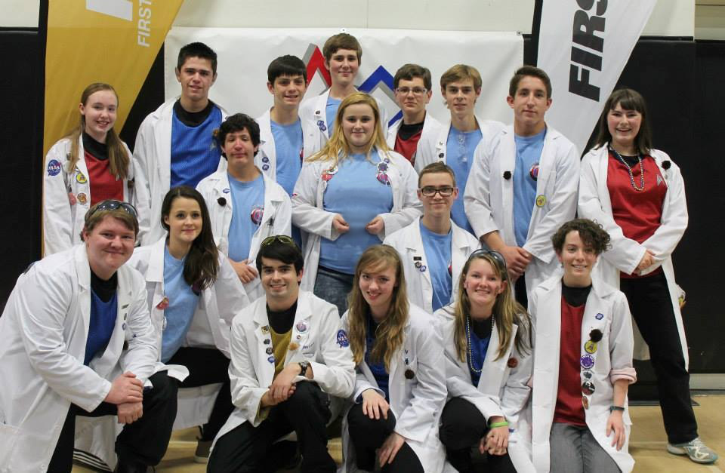*

*STAR DATE 1/29/15*

*SMC*

Our goals for the meeting were to get a few shields on the conveyor belt that would help guide the balls into a spot where the conveyor could pick it up. We also wanted to get all of our servos working and to finish changing out the motors. We decided first that we should change to Andy mark motors because they all have built in encoders. We then learned as we were changing them that they were too wide for the robot and we had to shift the wheels to different positions so that the motors could fit. We then found that in the back of the robot the two servos we have for grabbing the scoring tubes were in the way of getting the motors on so we had to shift them in so that the motors could fit.

After we got the motors on we tried driving around and the robot was super slow and our suspension would sag because the motors themselves were geared more for torch but the chassis was made for speed. Because of this we found that we had to put on the older motors and just have two encoders. To do this we had to unwire the Andy mark motors and rewire the other motors. Then we had to put the older motors back on attach them to the wheels.

After we finished this we took off the conveyor belt and cut some knew side shields for it we also put a shield on the front to put all of our sponsor stickers on. We then put the conveyor back on and it worked it picked up the balls way more quickly that the Zip tie intake. after we had accomplished most of our goals we tried to do some driving but found that one of the servos that releases the balls from the bucket was not getting power so we thought that that was it the wires because we had spliced those wires into a phone cable so that the wires were kept out of the way as we raised and lowered the linear slides.

We then got out our millimeter and began testing to see which wire was giving us the problem then we narrowed it down to the black wire. We then took off the heat shrink from both sides and saw that the wire was not connected. To fix this we decided to solder the wires together so that they would be stronger that before after we did this we put the heat shrink back on and the servo worked.

After that we had gotten our whole robot pretty much working and so we then decided that we would do some drivers practice. The drivers practice started out well but as it went on we found that the string that we were using to lift our linear slides kept fraying so we brought in some heavy duty wire that was once used to tow an air plane in the air with and decided to try that. That wire was really durable and did not fray easily.

We then had to braid the wire together to keep it from unraveling. We then braded some of the wire together and got it on the robot but we found that the wire was too thick and that we needed some thinner wire. So we had some if the team mates braid some more wire while others were doing drills so that we could learn to drive very well. Also had a group of team members with the mentors help twist some of the same wire using a drill and to but some wax on it to make it very durable. After one set of this string was made we put it on the robot and tried raising and lowering the linear slide and we found that the slide would not come all the way down. Because the wax that we put on it stuck to itself and the force of gravity and the weight if the slides could not bring it down. We decided to go with the braided string and to make some extra so that we would have some spare. After this was all finished we did some more drivers practice and re-recorded for the promote video.

*STAR DATE 1/30/15*

*SMC*

Today we called the meeting to get some more drivers practice for our team mates who will be driving in the competition in Vegas. We also wanted to get a few hardware changes done. We started with the bucket that is used to score balls there were two screws in it that would stop the balls from rolling out into the scoring tubes. The screws were holding a servo on to the bucket se we then took the servo off and put in flat screws so that the balls would roll out. Our other change was to put a metal plate on the plastic backing that is by our conveyor belt that plastic helps the balls go up into the bucket. The plastic would bend and the balls would not go up so we put some metal there to help the balls go up.

When we started drivers practice we burned out one of our front motors. So we had to replace it but we noticed that we were getting low on motors because we were burning out so many. After we burned out the motor one of our team members wanted to take the motor apart to see what was wrong with it and we found that in its gear box there was a plastic gear that had cracked. Then the member was wondering if that is what was wrong with all the motors but the mentor told us that some of the motors the motor itself had broken not the gear box.

We then than thought that maybe we could take two broken motors one where the gearbox was working the other where the motor itself was working then maybe we could put the working gear box onto the working motor and it would work. This is legal because the roles say that you can’t modify the motor but you could change out the gear boxes so this was legal because we were just changing out the gear boxes not modifying the actual motor. We then tried this with one motor and it worked.so we then went through all of our dead motors and got about 20 motors to work. We saved about 400 dollars in motors.

After we had changed out the front motor we were able to do some drill like mowing the rolling goals onto the ramp from different positions. After we had done some drill we actually drove with the time the way we would in the competition. The last thing we did was to make a driving strategy. We are going to knock out the kick stand and then collect 4-5 ball then we are going to move as many rolling goals on the ramp as we can and then before end game we are going to raise our arm to the center goal and when end game starts we will score in the center goal and quickly drive up on the ramp.

*STAR DATE 2/2/15*

*HMC*

Tonight we worked on giving our team members more driver practice in preparation for our upcoming tournament in Vegas. We also took care of a few more minor hardware changes. One of the main things that our team worked on this week was a solution for the static on the field which has been shocking and freezing our NXT. At our last tournament in Palmdale we had issues with this, and supplemented our problem with a simple copper wire attached to the bottom of the robot. Even though it helped as a temporary solution, it wasn’t consistent enough to satisfy us and so with two Regional competitions coming up, we began some serious brainstorming to correct the issue.

*STAR DATE 2/6-7/15*

*BP*

On February 6th, we arrived at Northwest Career and Technical Academy to check-in for the Las Vegas FTC regional competition. We set up our pit and headed over to software and hardware inspection. After inspection, we started testing our autonomies. Our programming team made some adjustments, and we had our driving team practice driving. We then were called for judging.

After we had gotten out of judging, we discussed how judging went. All of us were very confident in what the judge’s facial expressions and what questions they asked. We all headed out for the night, knowing we had to be there bright and early the next morning.

We all arrived back at the venue for the competition early the next morning. We started having our drivers practice right away. All the qualifying matches went well, but we were not an alliance captain nor were picked for an alliance.

While at the competition, we won the Rockwell Collins Innovate Award and were happy with how the team did. We discussed what did well and also what we could do better.

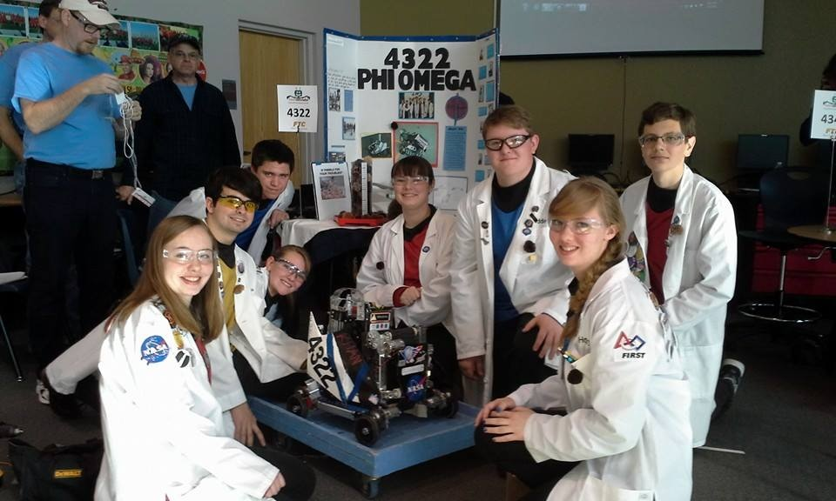

*STAR DATE 2/9/15*

*JL*

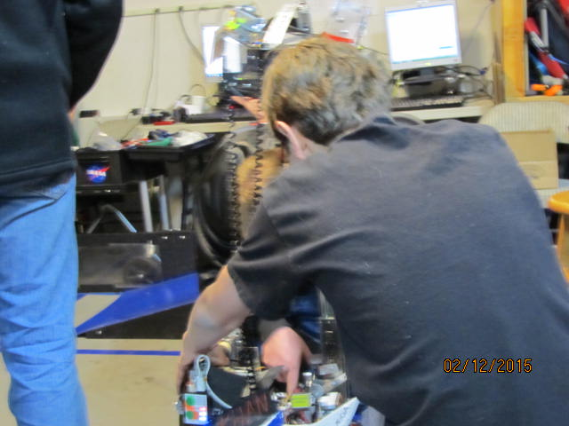Tonight we undertook the massive job of rewiring the robot. We have determined that the robot’s information wires and power wires have been routed too close to each other. We have also determined that since our motor controllers have been building static due to their being mounted on painted metal.

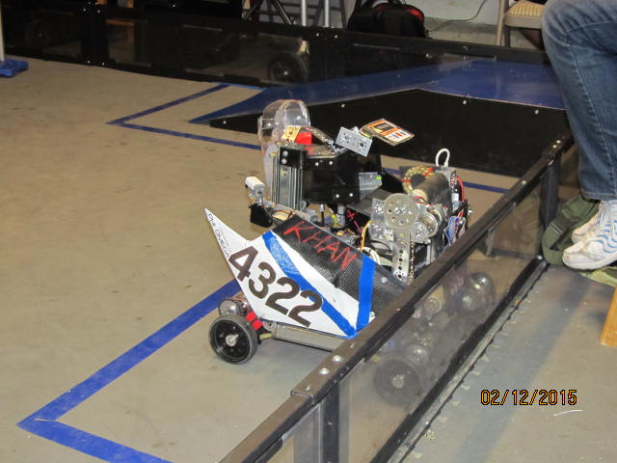We moved the motor controllers to the back of the intake conveyor’s back plate. We then routed the information cables across the top of the intake and the power cables down into the chassis in order to prevent them from generating interference with each other.

*STAR DATE 2/12/15*

*JL*

Tonight we prepared for the Los Angeles regional championship in Monrovia CA. We spent most of the night in driver practice with a high score of 279 points without autonomy. We have also begun working on different strategies including one in which we immediately drop the pre load ball in the medium tube rather than dropping it during autonomy. Another strategy that we worked on was putting one load of balls in the 90cm goal rather than putting it on the ramp. We then spent the second half of the meeting packing our equipment for the competition this weekend. We hope to do well this weekend and are looking forward to doing our best.

*STAR DATE 2/14/15*

*BP*

Today we competed in a competition at Monrovia High school. We arrived early in the morning so we could set up our pit area quickly and without delay. After we finished setting up we headed to judging.

After judging, we discussed how it went on our way back to the pits. We continued preparing before opening ceremonies. Afterwards, we went back to the pits to make some adjustments on our autonomies. We got some practice in for our drivers before each of their matches.

After the awards were over, we packed up our bot and headed to dinner. While at dinner we discussed the tournament and what went right and wrong. We left there with clears minds and headed home.

*STAR DATE 2/16/15*

*EP*

Tonight’s meeting, we invited our sister team to come for a large-scale debrief after the Monrovia Regional Championship. There is a very small chance that we will make it through to the Super-regional competition, but we assumed that we won’We opened with prayer, then stood around in a large circle to discuss the previous tournament, then discuss plans for the future competition year.

The first of the things we had to discuss was where we were going to be meeting the next year. Our host family that had been helping us with the donation of their garage for the past several years could not support the teams another year and asked that we find a new venue for our meetings. A few of the ideas were to ask local schools for a room on their campus, or to ask the local aero-institute for assistance. However, the general problem with either was that we would have to set up our gear each meeting, then pack again at the end. As it stands, it looks like PHI Omega will be meeting at the garage of one family on the team.

After this important topic, we switched to discussion of fundraisers and outreach events to set up over the off-season. First off, we discussed asking several local restaurants to help us with fundraising. They had ways we could call in to their office, and they would have a day where part of the proceeds for the day would go to the team. Other fundraisers we discussed were our yearly yard sale and the Yankee Candle sale we have each year around the holidays. Concerning outreach, we discussed walking down our local boulevard with the robot to promote FTC and First. We also will be helping with the VEX workshop we assist with each year. Another we talked about was the demonstration of our robot at local schools. Finally, we will be heading up a booth at our local county fair. Here, we will be demonstrating our robot with several other local FTC and FRC teams to several thousand people each day we come.

After these long talks about the year to come, we talked with each other for a few minutes until the end of the meeting. We then closed out the meeting in prayer and left, still waiting for the results from the Regional competition.

*STAR DATE 2/23/15*

*EP*

Tonight we started by discussing the plans for the night while waiting for the rest of our team members to show up. Then, we began in prayer. As we have made it to Super-regionals, we began work immediately.

The majority of the night was taken up by driver practice. We want as much practice as we can get before we go to the tournament. The practice started off great and continued that way for the rest of the night. Matches done by our more experienced drivers were scored higher than any matches we had ever done. Our highest score shot past everything we’ve ever accomplished, coming in with no autonomy score at 298. While it may not be the best in the world, it was quite an accomplishment for us. We maintained our strategy we use at competitions and performed the same maintenance we do as well. Screws were kept tightened and batteries were regularly changed to accommodate for power drop. Everything went well.

While this was going on, those of the people who were not driving were working on updating our hardware section of our notebook as well as building spare parts for our competition. We completed two new back flaps for our robot’s output as well as one brand new bucket for mounting. The plan is to mount this next meeting, as our current bucket looks less than presentable.

After we cleaned up the garage, we gathered all the team members and settled down for a debrief of the night. We discussed what needed to be done next meeting, including the mounting of the newly built bucket. We also discussed the need for a new belt for the intake to be made, as it has been falling apart. One of the team members has volunteered to take care of it. Finally, we closed out in prayer and left.

*STAR DATE 2/26/15*

*BP*

Tonight we started a new rewire of Khan. There were several power issues, so we added new devices to help with it. We used multi-port power connectors to jump the electricity into the motor controllers. We also used ferrels on each of the wires going into the motor controllers for better electrical connection. We added a ferrite choke to the NXT data cable to help filter out static.

While the hardware team rewired the robot, a couple of our notebook team members drew pictures of some of the parts of Khan to add to our trifold/notebook. They also made a list of materials we needed to get to build a bigger board for competition.

*STAR DATE 3/2/15*

*EP*

We began tonight’s meeting by discussing what needed to be done for the night while waiting for the rest of the team members to arrive. After everyone came, we officially opened the meeting in prayer, then discussed in detail the goals for the meeting some of which included the mounting of the new bucket, the building of one more, and the start of driver practice. After this, we discovered our recently ordered batteries had arrived, so we put them on charge. Then we began working on each task at hand.

The first and foremost of the tasks we had to tackle was the mounting of our recently rebuilt bucket. We had one of our team members hold the bucket next to our slide-arm system while another marked locations for mounting holes on the aluminum crossbar we built last meeting.

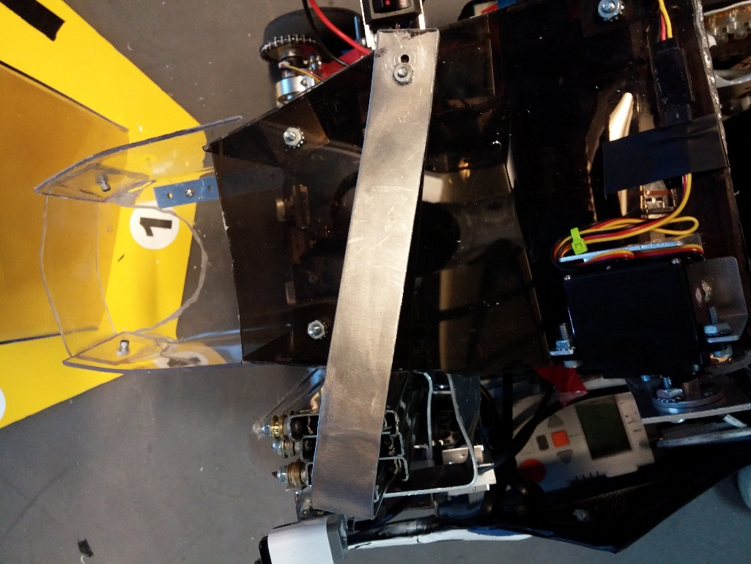

After finding accurate locations for the holes, one of the two team members got to work on drilling the holes. When these were finished, the team member got to work on mounting the crossbar, then the bucket to it. This was somewhat easy and was completed within the first hour and a half.

During this, another of the team members was working yet another replacement back flap for the bucket’s output section. It’s always good to have backups, and one of the phrases we live by is “make sure you have a backup of the backup”. This was an easier task than the bucket-mounting and was done in a half hour.

A secondary task we had for the night was the continuation of our shooter project. The team member that was heading up the project had come to that meeting with a good idea of what he wanted to experiment with for the release mechanism. However, tests for the spring rate needed for distance of the shot had not concluded, so the tests continued through the night.

After the bucket had been mounted to the robot, we decided to begin driver practice. We had to get to work quickly, though, because the meeting was almost over. Our first driver pulled one of our new batteries and plugged it into the robot. Then we set up the field for a match and began. The autonomy had a hiccup, however, because we forgot to plug the encoders in after the big rewire, and it ran into the goal it was aiming for. It did not stop, and we had to execute an emergency stop of the autonomy period. We decided to continue with the match and switched to the teleop period. Our driver found, however, that the goal had gotten stuck under the robot’s rear, and was being towed around by it. The driver tried to get it loose, but eventually decided to try to shake it loose on the ramp. Unfortunately, our arm was raised up some, and that combined with the higher-powered battery allowed the robot to fall over forward on the ramp, cracking the top of the new bucket.

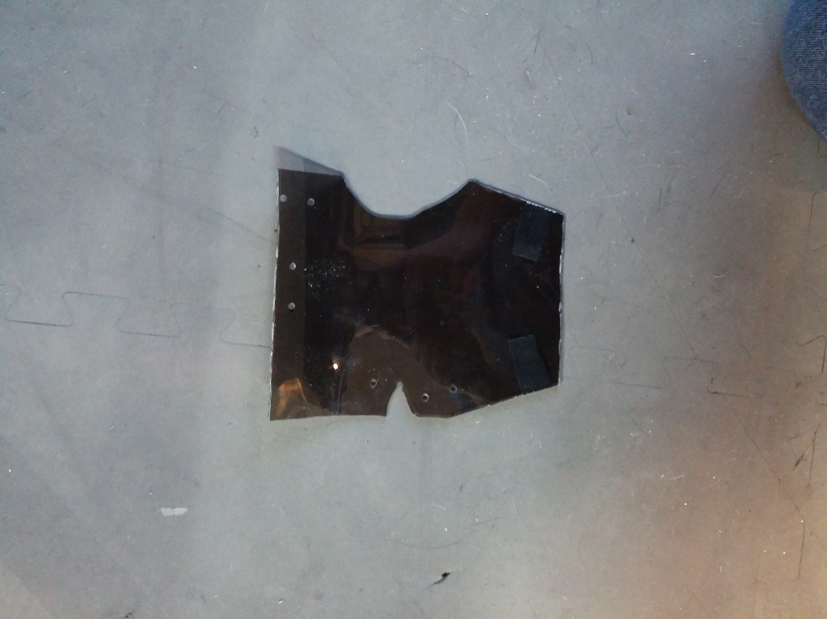

After this “shattering” blow at the end of the night, we decided to close out the meeting. We cleaned the field up and gathered around for debrief. We discussed what we had accomplished for the night and talked about news, such as our upcoming fundraiser. After this, we closed in prayer and left the garage.

*STAR DATE 3/5/15*

*SMC*

Tonight we started the meeting with some goals that we wanted to accomplish. After we made the goals we split up the tasks so that we could get them done faster. Our goals were to replace the top panel on our bucket because in our previous meeting we were doing drivers practice and the robot fell over and broke that part of the bucket. Also we wanted to get our bug bot working so that some people could get defensive driving practice. We were considering putting a shooter on the robot so that we could shoot into our autonomies.

We started with making our new bucket top we had to trace out the new top and then we cut it using the rotary tool. After we had our top cut it was time to install it onto our bucket to do this we had to drill the two mounting holes. We also had to drill the holes for the servo attachment and screw the servo in. Then we screwed it in and it fit well.

The previous meeting we had just finished wiring the bug bot so all that was left was for us to put in the NXT. For a long time we could not find one but we finally did and we installed it. Then we were trying to connect the computer to the robot but we could not. Later we found that the robots blue tooth was off and the computers little Bluetooth chip was not in the computer. These reasons were why we could not connect the NXT to the computer.

Next thing we did was to come up with a shooter idea. Then we decided on one that the shooter would be made out of PVC pipe. And it would have two springs to propel the ball out. The shooter would only have room for the little ball. We decided that the shooter would be fixed to the robot it would not move. This would take away some of the error and this would allow the program to not be as complicated.

This was all the hardware that we did. We also decided that it would be cool if in the engineering note book there were summaries of some of our coolest ideas and of things that make us different. This allowed the judges to just see the page and see some of our main things. We got a total of about 1.5 hours of drivers practice. We ended the night with planning some more outreach. We decided that we would go to the AV Air Show and present our robot there.

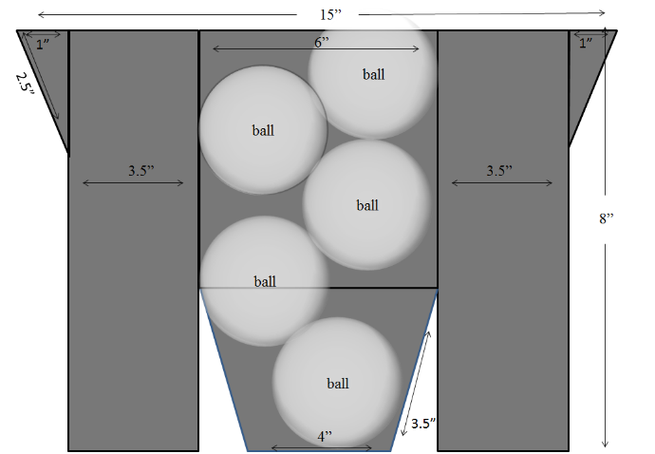

Bucket plans

*STAR DATE 3/9/15*

*HMC*

Tonight we primarily did driver practice, but we also worked on building an extra bucket and a shooter. Our driver practice consisted of team members taking turns driving Khan. Also, we’ve been working on creating duplicates of parts that are important to our robot for the upcoming Super-regionals. Tonight we worked specifically on a bucket duplicate. Another one of the main things we worked on was a shooter. We are hoping to have it working in time so that we can use it at Super-regionals.

Also, we have a fundraiser coming up this Wednesday at our local Sweet Frog, so we have been sending out invitations in hope of getting a decent income which can help us pay for upcoming tournaments and outreach.

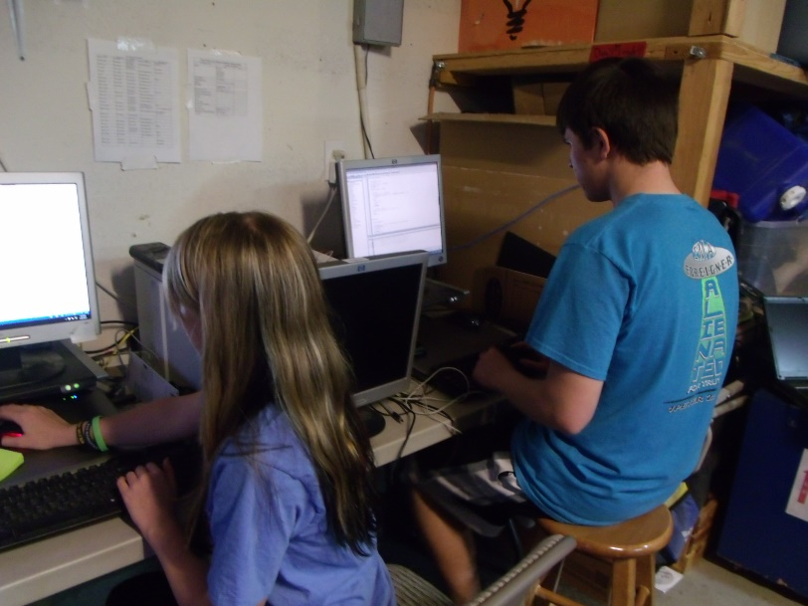

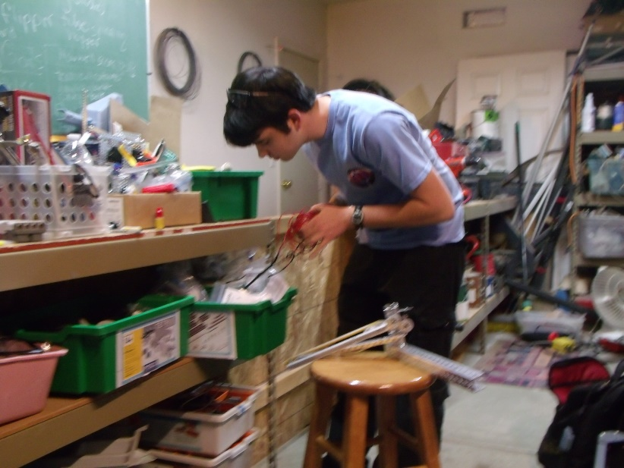

*STAR DATE 3/16/15*

*BP*

Tonight, we started out the meeting with opening prayer. After that, we spoke about what had to be completed for the night. A couple of our hardware members worked on a bugbot for and air show we are participating in this weekend. They attached an arm and finished wiring the bugbot so it was completed before this weekend.

Our software team coded some autonomy functions. They also found bad encoder readings on the winch motor, and on one of the wheel motors. This fixed a little of the issues in our autonomy.

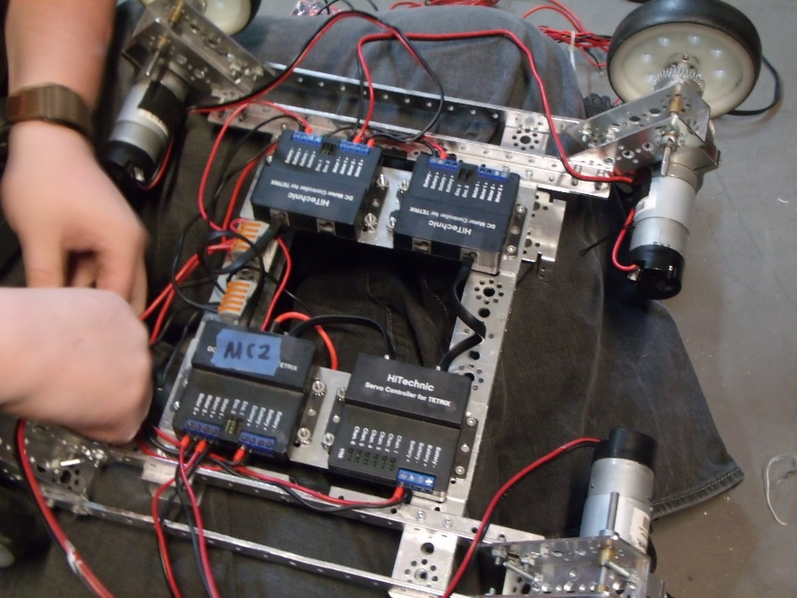 Our notebook team worked on making sure all the meeting logs were written, and that most of the logs had pictures. They also double-checked the hardware section, software section, and outreach section to make sure they were all in order. We then closed for the night.

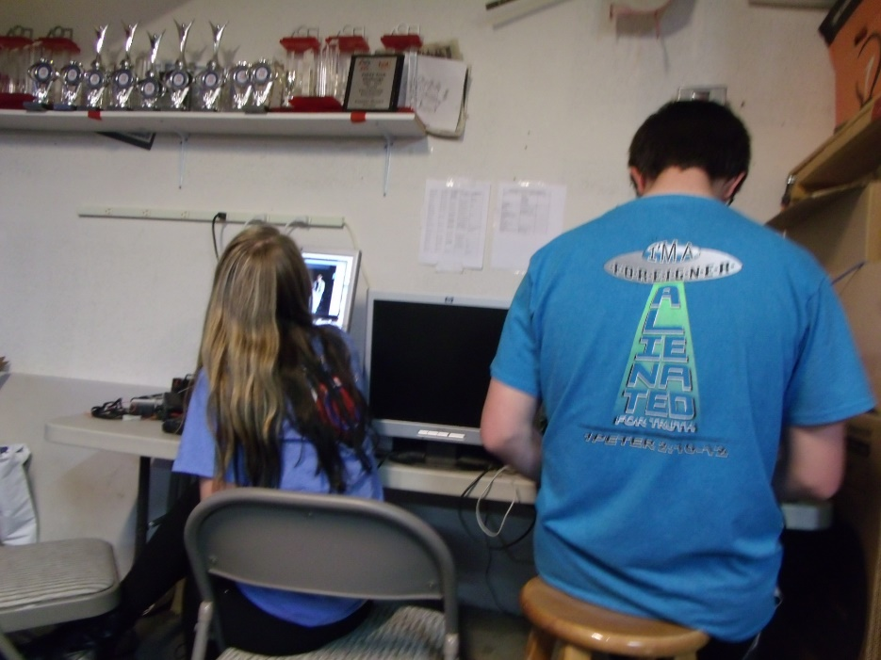

*STAR DATE 3/19/15*

*HMC*

Tonight we worked mostly on hardware. First, we had to put the new conveyer belt on our robot. We had to stop and re-measure several times to make sure it fit correctly. Then, we started to do some driver practice. Unfortunately, we came across some issues so we had to stop and see what was wrong. In driver practice the robot wasn’t picking up the whiffle balls correctly. Nothing has changed on the robot, and yet it suddenly appears to be smaller in dimensions. The robot has apparently shrunk!?

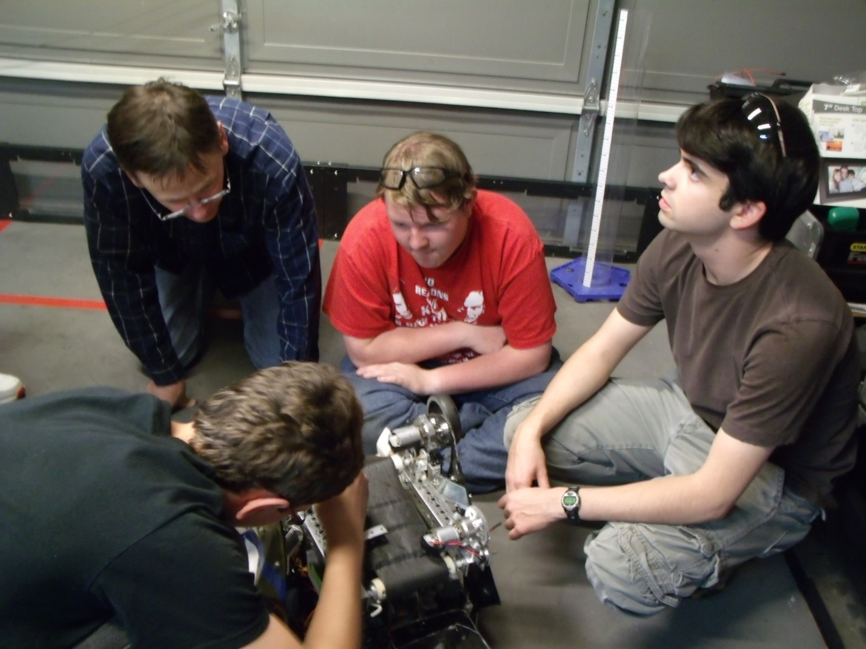

*STAR DATE 3/23/15*

HRC

We started tonight by opening in prayer. We worked on our boards that we’re going to take to super-regionals. Specifically, we worked on the outreach and fundraising board. We spread netting, made out of polyester, across the “guts” of our robot. Our drivers practiced driving and we’re able to boost our average score throughout the night. The front shield got broken so we made a new one. We refreshed our judging and closed in prayer.

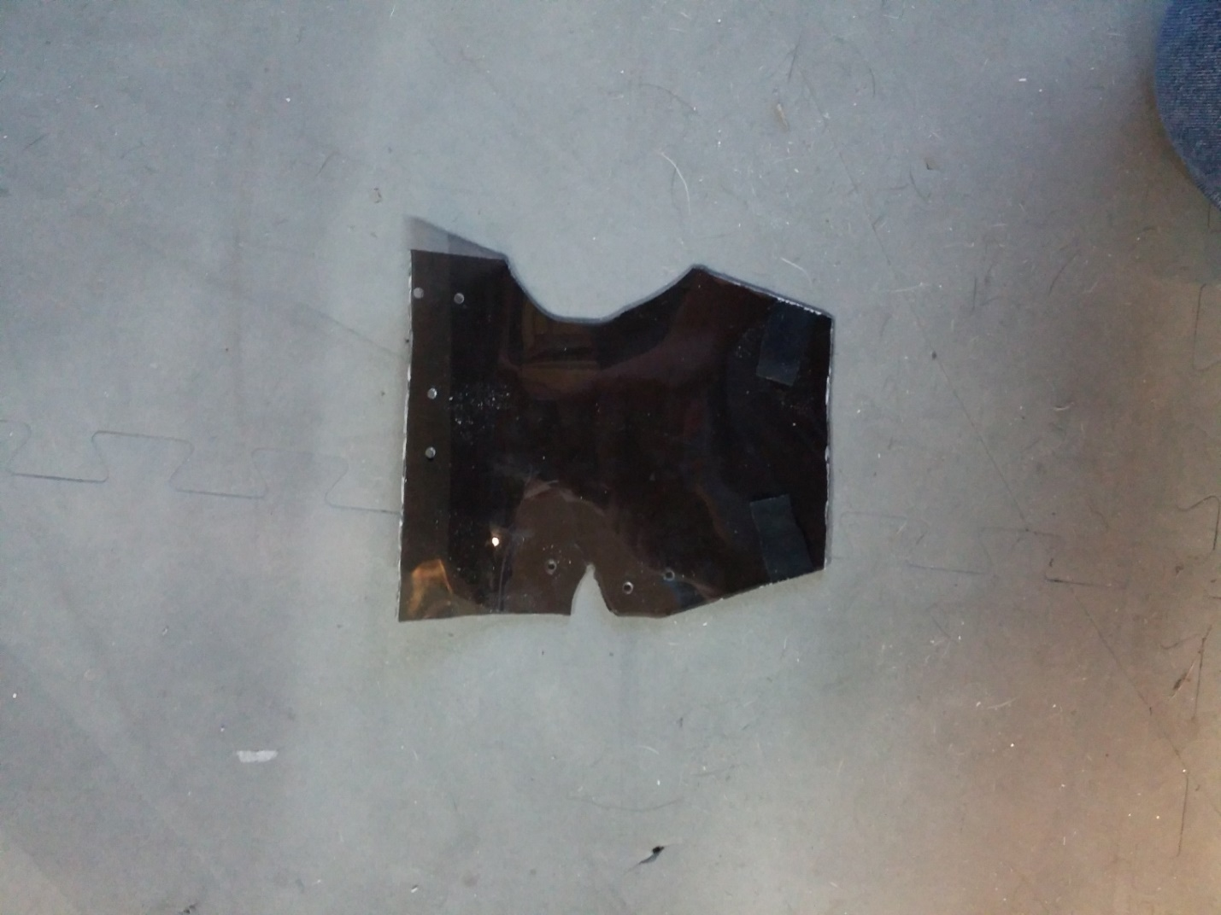

# HARDWARE



**KHAN'S LOG**

*Robotics: the final frontier. These are the adventures of the robotics team PHI Omega. Its ongoing mission: to explore strange new ideas, to seek out new designs and new mechanizations, to boldly go where no team has gone before.*

For the 2014-2015 FIRST tech challenge year, PHI omega has committed itself to excellence and to go above and beyond the challenge. In this spirit PHI omega has set out to build a robot superior in every way: from hardware to sensors to software. It is for this reason that we have decided to name our robot "Khan", a robot that, in the words of its namesake, is better at "everything."

****

**Khan's log**

**Star date 6/7/14**

In order to build a superior robot, our team has opted to start work early. We have chosen to start with an improved chassis.

Chassis design requirements:

* It should be based on a proven design
* It should be predesigned
* It should be modular
* It should have high mobility
* It's wiring should be clean and accessible

To meet these requirements we began by reevaluating our traditional "Kraken" chassis that was designed five years ago by a former team member.

Pros:

* High ground clearance
* Fairly modular
* lightweight and rigid Last year's "Kraken" under deconstruction



Cons (no pun intended):

* It requires some parts that we no longer have sufficient amounts of
* 45 degree motor nacelles tend to warp throughout the year

After brainstorming about the chassis for some time we have decided on a few features that could improve the old Kraken chassis.

* Single piece 3D printed or metal shop frame
* Fully enclosed nacelles rather than open C-channels
* Integrated suspension to cushion the sensors and electronics

**Khan's log**

**Star date 6/27/14**

For the last week all the FIRST teams in the valley from FTC and FRC have gathered at a local middle school to host a robotics workshop for local middle school students teaching them robotics basics using the VEX robotics system. During the last week we have had the chance to get some advice from our fellow teams on computer aided design. One of the teams recommended that we look into using Auto Desk CAD software.

The VEX robot named "Colonel Sanders" that won the workshop championship.



**Khan's log**

**Star date 7/8/14**

After several attempts, we have not managed to get Auto Desk to function on our computers. So in place of Auto Desk, we have chosen to continue on with our plans using the Google SketchUp CAD software that we learned how to use at a seminar given by another team from our area.

Last year's robot "Pythagoras" built in SketchUp.



**Khan's log**

**Star date 8/20/14**

After about a month of CAD work and consulting with the engineers at NASA Armstrong's 3D printing lab and metal shop we have learned a few valuable lessons. For one thing we learned that the max printing size available to us is 14"x14" which is too small to print the entire chassis out of one piece. We have thus decided to use a multipart frame that can be easily adapted to the design requirements of the as of yet unannounced game. We have also settled upon a name for the new chassis design. This being the fourth rendition of the Kraken chassis, it will be known as the KR4 chassis.

Some features that we are going to implement are as follows:

* Unlike TETRIX metal, we will have full rings of screw holes around every axel hole
* The chassis will be composed of three types of components: nacelles, rails, and cross spars
* The nacelles will be 3D printed out of ABS plastic and will be equipped to move independent of the chassis in order to act as suspension.
* The rails and cross spars will be metal shopped and the rails will be equipped to allow the nacelles to move.

KR4 cross spar KR4 Rail

 

KR4 Nacelle KR4 Chassis

 

**Khan's log**

**Star date 9/2/14**

We are almost ready to begin fabrication on the new KR4 chassis. We have found a converter to change the SketchUp .skp file into the .stl file required by the 3D printer at NASA Armstrong. We have also come upon some design flaws in the KR4 cross spars. The problem we have found in the cross spars is that since they are a closed rectangular tube, there is no way to mount our motor controllers in the compact way that we had originally decided upon. We also have learned that the complex nature of the cross spars will make it difficult for the NASA metal shop to manufacture. To remedy these flaws, we have designed a new system by modifying two 16" TETRIX C-channels and making metal brackets to mount them to the rails.

KR4 bracket.



**Khan's log**

**Star date 9/4/14**

We have had an epiphany that it would be much easier to have the brackets 3D printed so we have quickly CADed up a new model to be made of plastic.

KR 4 plastic bracket



**Khan's log**

**Star date 9/6/14**

Today the game was announced and it is called "Cascade Effect". It is played on a normal sized field that is quickly covered in two sizes of whiffle balls that are to be scored in three sizes of tubes.

Some important requirements for the robot are:

* An effective intake for the balls
* A fast lift system
* A system to manipulate and control the rolling goals
* A fast robot to complete the various tasks
* A robot with enough grip to climb the ramps

**Khan's log**

**Star date 9/8/14**

Today is our first build meeting of the competition year. We have already brainstormed several ideas for the various elements of the robot.

We have worked out that the intake should require the least amount of accuracy as possible and be able to automatically count the number of balls coming in so as to exceed the limit of five balls. To make counting easier, we have proposed a design that uses a ABS plastic tube with brushes to intake the balls from the ground into the tube. Paddle wheels inside then convey the balls up the tube past an ultrasonic sensor to be counted. Once a ball arrives at the top of the tube, it is stopped by a door until five balls have been taken in. Once the ultrasonic counts five balls, the robot will begin flashing its lights and the intake brush will shut down. The whole tube mechanism is then raised on top of a chain stabilized three stage arm that was used two years ago on our robot in "Ring It Up".

A concept drawing of the "Da Vinci" prototype tube.



Another accomplishment of tonight's meeting was the completion of our first 3D printed nacelle. We are excited to see how clean it makes the meshing between the two gears and how rigid it is. This is the first 3D printed part that PHI has ever produced and we are excited to see what else we can do. Mk. 1 series KR4 Nacelle



After a little more CAD work during our meeting tonight we have a tentative 3D model of the Da Vinci tube prototype.



**Khan's log**

**Star date 10/2/14**

**TODAY IS A GLORIOUS DAY!!!!** Last night, NASA delivered the final components of the chassis, the KR4 rails. With the new rails we were able to complete the chassis and are now able to start running trials. The wiring has worked out just to plan with the wires concealed and protected inside of the modified C-channels.

KR4 chassis undergoing its first test runs.



We also have a working model of the chassis so we can experiment with various arrangements of its modular parts as well experimenting with the geometry of our new prototypes.

Google SketchUp model of the KR4 chassis.



We are currently working on making a camera arm to enable us to mount a camera to watch how the suspension reacts to various obstacles on the field.

 Suspension contracted.

 Suspension extended.

 Suspension over extended. (BAD)

After further testing we have found that iff enough force is put on a nacelle, it will shater so to fix that we have made a new reinforced 3D model to be printed by NASA.



**Khan's log**

**Star date 10/9/14**

Work on the "Da Vinci" tube has progressed some and we now have a semi functioning tube. We have also opted to use a light sensor instead of an ultrasonic sensor to count the shadow of a passing ball. We also put LED strips in the tube to help the robot communicate visually with the drive team when it is fully loaded.



**Khan's log**

**Star date 11/15/14**

Well our house of cards has come crashing down. The four stage riser arm will not work no matter how many thing we try. We hypothesize that the problem lies in the sheer amount of resistance given by the chains. Three years ago the arm worked just fine because it was only two stages and weighed much less. We have also discovered that both the paddle wheels and our make shift duck tape conveyor belt have jamming issues when a ball comes into the tube. We have spent many hours working on correcting these problem and have already called several extra meetings however he have yet to see any improvement. We are considering scrapping this riser arm system in favor for something a bit simpler, like drawer sliders.

Four stage arm stored. Our facial expression.

 

Four stage arm extended.

